Egypt and Jordan! November 28 to December 10, 2026

This is a fully escorted tour from when you reach your hotel in Cairo until the last farewell dinner in Amman. It includes intra-vacation air flights (Cairo to Luxor; Aswan to Cairo to Amman) and a 4 nights Nile River cruise, all for $4,929.00. International flights on your own. (Just Egypt is $3,379.00)

Special Features Included in this Tour:
• Guided sightseeing in Cairo with a visit to the Grand Egyptian Museum
• Guided visit to the Sphinx and the Great Pyramids of Giza
• Four-night Nile Cruise between Luxor and Aswan
• Guided sightseeing tour in Luxor with visit to the Karnak and Luxor Temples, and the Avenue of the Sphinxes
• Guided walking tours of the Temple of Horus and Kom Ombo
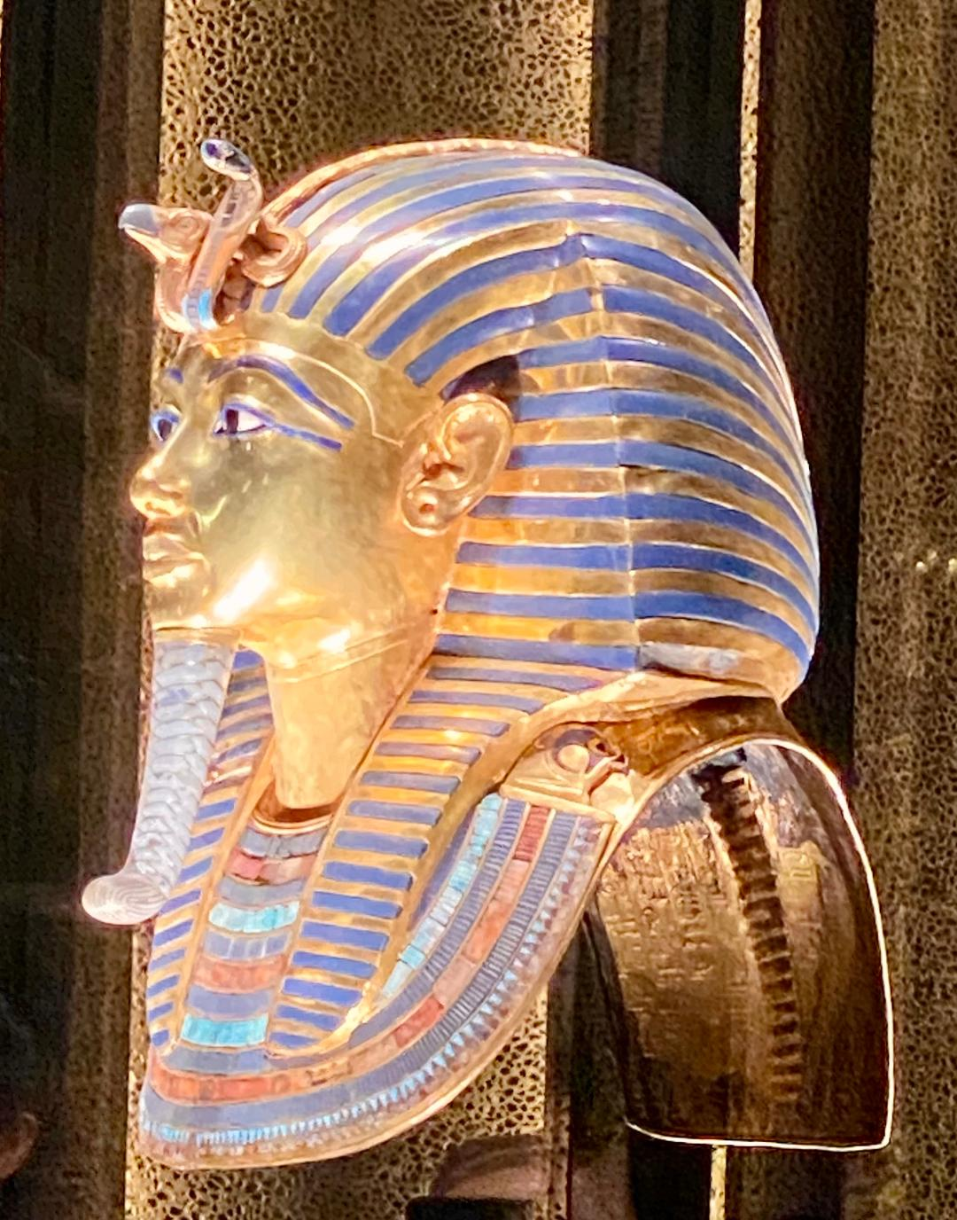
• Cruise on a local felucca (traditional wooden sailing boat) around Kitchener’s Island and the Mausoleum of Aga Khan at Aswan
• Four-wheel drive tour in the desert of Wadi Rum with overnight in a luxury camp
• Guided walking tour with highlights of Petra
• Visit to St. George’s Church & Archaeological Museum in Madaba
• Orientation walks on Mount Nebo and Bethany beyond the Jordan

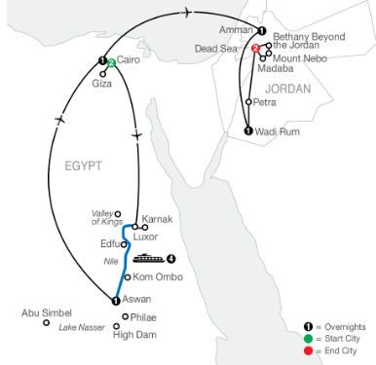
Day 1: This is your day to arrive in Cairo and make your way to your hotel that awaits you. Relax until you need to meet with the rest of the group and your tour director for a welcome dinner and information. (D)

Day 2: Your Egyptian discovery starts in the vibrant city of Cairo, located on the River Nile, with a guided sightseeing tour that features a visit to the Grand Egyptian Museum. Later, a short drive to Giza is the start of an iconic visit to see some of the most recognizable landmarks in the world, including the Sphinx and the Great Pyramids. (B)

Day 3: Today, depart Cairo and fly to Luxor. Embark your cruise ship for the start of your Nile River Cruise. Start to get acquainted with the ship and enjoy lunch on board. This afternoon, join the guided sightseeing tour to see the breathtaking Karnak Temple, the largest temple complex in Egypt, and the Luxor Temple, also known as “the Southern Sanctuary”. (BLD)

Day 4: Enjoy some free time to explore more of Luxor at your own pace, once the site of Ancient Thebes and still home to an amazing number of Egyptian monuments. Alternatively, join an optional excursion to the West Bank. Back on board, enjoy the captain’s welcome cocktail party and set sail for Edfu. (BLD)

Day 5: Today, in Edfu, visit the impressive Temple of Horus, one of the best-preserved temples in Egypt. Return to the ship and enjoy lunch while sailing. Call at Kom Ombo for a guided walking tour featuring the temple dedicated to the crocodile and falcon gods. Enjoy some free time to browse. Continue sailing towards Aswan and this evening enjoy a Galabeya (traditional Egyptian gown) party on board. (BLD)
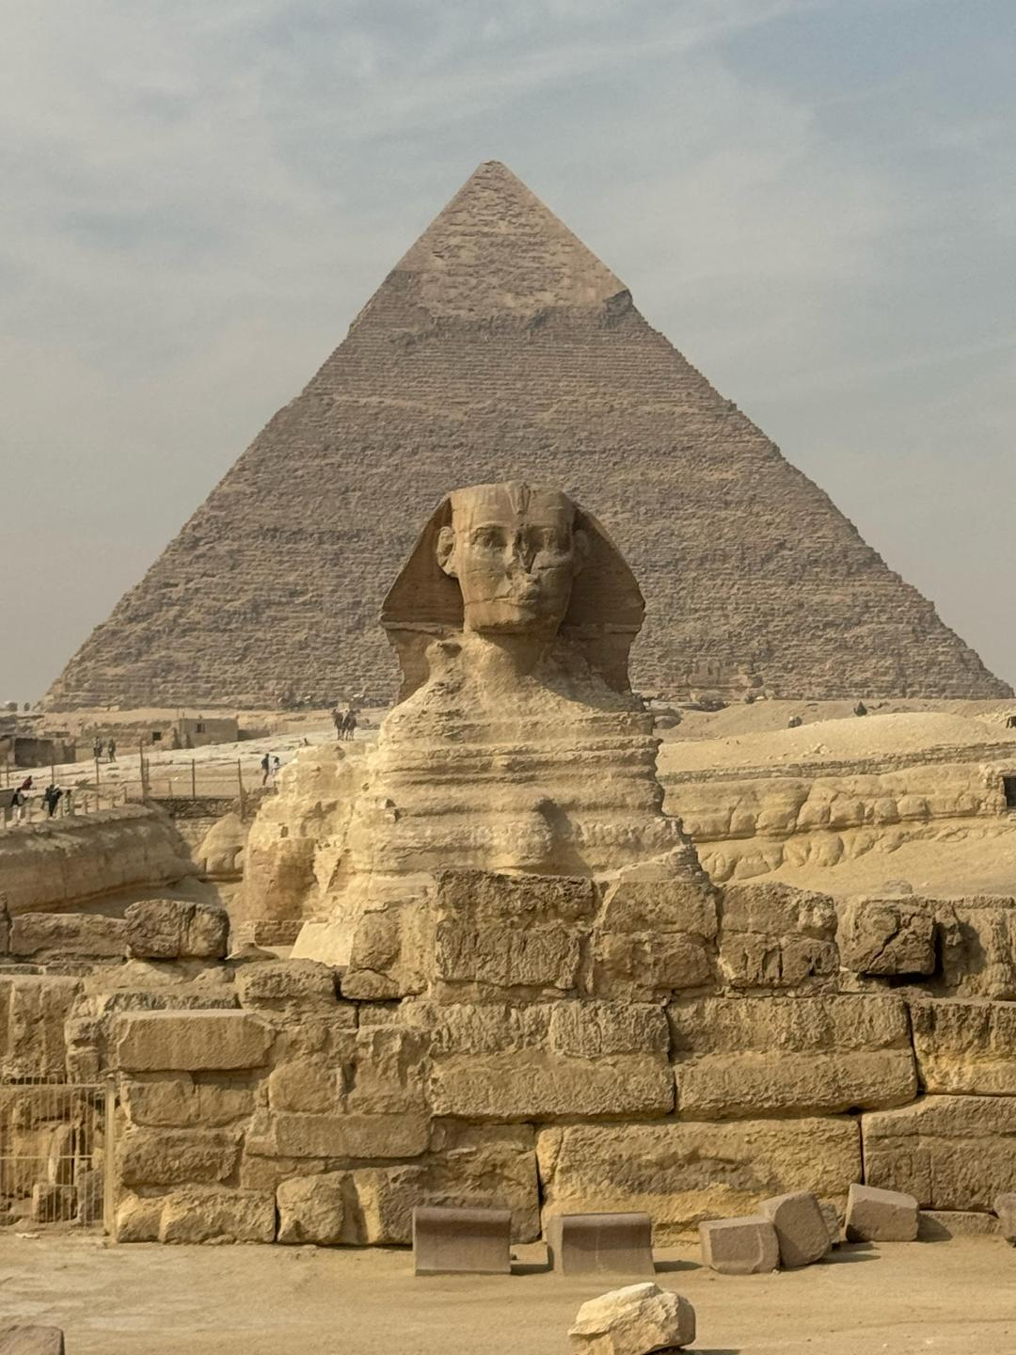
Day 6: Today discover Aswan, the land of gold that has kept the treasures of the pharaohs for centuries. Sail on a felucca (traditional wooden sailing boat) around Kitchener’s Island and the Mausoleum of Aga Khan. This evening, on board your ship, take part in a Nubian Folklore presentation. (BLD)

Day 7: This morning, disembark your ship and transfer to your hotel. Enjoy an afternoon and evening at leisure to explore more of Aswan independently or join an optional excursion. The optional excursion is to the High Dam, the Philae Temple, and the Unfinished Obelisk. (B)

Day 8: Depart Aswan this morning and take a flight to Cairo. Enjoy an afternoon at leisure in this exciting city before joining your travel companions for dinner at your hotel. (BD)

Day 9: From Africa to Asia! Today, leave Egypt and fly to Amman, the captivating capital city of Jordan, famed for its impressive architecture and rich history. Meet your Tour Director who will accompany you during your Jordanian discovery and enjoy dinner in the hotel. (BD)

Day 10: This morning leave Amman and head for Wadi Rum. Enjoy a fascinating 4-wheel drive tour in the stunning desert landscape of Wadi Rum and see the Seven Pillars of Wisdom made famous by Lawrence of Arabia. Overnight under canvas at a luxury camp located in the heart of Wadi Rum. (BD)

Day 11: Arrive in Petra for a guided walking tour. Enjoy an unforgettable experience as you walk down the Siq, the narrow gorge made famous by Indiana Jones. Stand in awe in front of the iconic and famed treasury. See spectacular temples and tombs created out of the rose-hued sandstone, and sip tea in an authentic Bedouin tent. Later, continue to your hotel by the Dead Sea. (BD)

Day 12: A fascinating day awaits! Drive to Madaba, known as the “City of Mosaics.” Visit St. George’s Church, home to an exquisite mosaic map of the Holy Land, and explore the Madaba Archaeological Museum. Continue to Mount Nebo for an orientation walk on the legendary mountain ridge. Reach Bethany Beyond the Jordan, where Jesus is believed to have been baptized by John the Baptist, and follow an orientation walk. Later, return to your Dead Sea hotel for a farewell dinner. (BD)

Day 13: Safe travels back home today. Your vacation ends with breakfast this morning (the nearest airport is Amman). (B)

Total trip cost: $4,929.00 per person, double occupancy. Egypt without Jordan cost: $3,379.00
Non-refundable Deposit Required - $500.00 per person
- email if interested: mamakukutravel@gmail.com; or call or text (570) 479-5454 -

1ELAINE COOK DBA: MAMA KUKU TRAVEL is registered with the State of Florida as a Seller of Travel. Registration No. ST41381. Fla. Seller of Travel Ref. No. ST41381

